Operation Analytics and Investigating Metric Spike

**A. Jobs Reviewed Over Time:**

* + Objective: Calculate the number of jobs reviewed per hour for each day in November 2020.
  + Your Task: Write an SQL query to calculate the number of jobs reviewed per hour for each day in November 2020.

-- From the below query we could see that to review one job is taking 1 day on an avg in november month

SELECT

DATE_FORMAT(ds, '%y%-%m-%d') AS date,

COUNT(*) AS jobs_reviewed

FROM job_data

WHERE month(ds)='11'

GROUP BY 1;

SELECT DISTINCT ds AS days,

(Count(job_id) *3600) / (Sum(time_spent)) AS no_of_jobs_reviewed

FROM asj_job_data

GROUP BY days;

**Throughput Analysis:**

* + Objective: Calculate the 7-day rolling average of throughput (number of events per second).
  + Your Task: Write an SQL query to calculate the 7-day rolling average of throughput. Additionally,
  + explain whether you prefer using the daily metric or the 7-day rolling average for throughput, and why.

select a.ds as day, a.throughput,

avg(a.throughput) over( order by DS ROWS BETWEEN 6 preceding AND CURRENT ROW) AS 7_DAY_THROUGHPUT_AVG

FROM

(select ds, count(*)/sum(time_spent) as throughput from asj_job_data group by ds)a

GROUP BY DS;

**Daily Metric:** Using the daily metric (raw throughput) gives you a snapshot of throughput for each individual day. This is useful for analyzing short-term fluctuations and pinpointing specific days with exceptionally high or low throughput. It's suitable for daily operational insights.

**7-Day Rolling Average:** The 7-day rolling average provides a smoothed, longer-term view of throughput trends. It helps in identifying trends and patterns over a week, which can be useful for understanding weekly cycles, identifying trends, and making longer-term capacity planning and resource allocation decisions.

**C.Language Share Analysis:**

* + Objective: Calculate the percentage share of each language in the last 30 days.
  + Your Task: Write an SQL query to calculate the percentage share of each language over the last 30 days.

SELECT LANGUAGE,

COUNT(JOB_ID) AS NO_OF_JOBS,

COUNT(JOB_ID)*100/sum(count(*)) OVER() as percentage_share FROM asj_job_data

WHERE DS BETWEEN '2020-11-01'AND '2020-11-30'

GROUP BY language

order by percentage_share desc;

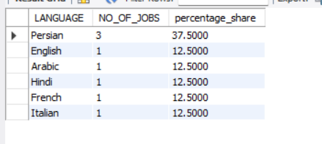

From the above query we could see persian language is double compared with rest all.

**D. Duplicate Rows Detection:**

* + Objective: Identify duplicate rows in the data.
  + Your Task: Write an SQL query to display duplicate rows from the job_data table.

SELECT DS,JOB_ID,LANGUAGE,EVENT,ORG,

CASE WHEN COUNT(*) OVER(partition by DS,JOB_ID,LANGUAGE,EVENT,ORG) >1 THEN 'DUPLICATE'

ELSE 'NOT DUPLICATE'

END AS DUP_STATUS

FROM asj_job_data;

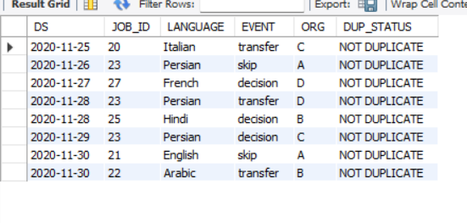

Hence all are records are distinct

***# Case Study 2: Investigating Metric Spike***

**A. Weekly User Engagement:**

* + Objective: Measure the activeness of users on a weekly basis.
  + Your Task: Write an SQL query to calculate the weekly user engagement.

select extract(week from occurred_at) as weeks,

COUNT(DISTINCT USER_ID) AS NO_OF_USERS FROM ASJ_EVENTS

WHERE EVENT_TYPE='ENGAGEMENT'

GROUP BY 1 ORDER BY 1;

**B.User Growth Analysis:**

* + Objective: Analyze the growth of users over time for a product.
  + Your Task: Write an SQL query to calculate the user growth for the product.

select years, a.weeks as week_num, a.new_users as active_user,

sum(new_users) over (order by years,weeks rows between unbounded preceding and current row) as cum_active_user

from

(

select extract(week from activated_at) as weeks,

EXTRACT(YEAR FROM activated_at) AS YEARS,

count(distinct user_id) as new_users from ASJ_USERS

where state like '%active%'

group by 1,2)a;

1. **Weekly Retention Analysis:**
   * Objective: Analyze the retention of users on a weekly basis after signing up for a product.
   * Your Task: Write an SQL query to calculate the weekly retention of users based on their sign-up cohort.

SELECT

DATE_FORMAT(cohort_start_date, '%Y-%m-%d') AS cohort_week_start,

DATE_FORMAT(DATE_ADD(cohort_start_date, INTERVAL 6 DAY), '%Y-%m-%d') AS cohort_week_end,

COUNT(DISTINCT u.user_id) AS cohort_size,

COUNT(DISTINCT e.user_id) AS weekly_retention

FROM (

SELECT

user_id,

created_at AS cohort_start_date

FROM ASJ_USERS

) u

LEFT JOIN (

SELECT

user_id,

occurred_at AS event_date

FROM ASJ_EVENTS1

) e ON u.user_id = e.user_id AND event_date BETWEEN cohort_start_date AND DATE_ADD(cohort_start_date, INTERVAL 6 DAY)

GROUP BY cohort_start_date

ORDER BY cohort_start_date;

**Weekly Engagement Per Device:**

* + Objective: Measure the activeness of users on a weekly basis per device.
  + Your Task: Write an SQL query to calculate the weekly engagement per device.

SELECT

DATE_FORMAT(occurred_week, '%Y-%m-%d') AS week_start,

DATE_FORMAT(DATE_ADD(occurred_week, INTERVAL 6 DAY), '%Y-%m-%d') AS week_end,

device,

COUNT(*) AS engagement_count

FROM (

SELECT

device,

DATE(occurred_at) AS occurred_week

FROM ASJ_EVENTS

) combined_events

GROUP BY 1,2,3

ORDER BY week_start, device;

**Email Engagement Analysis:**

* + Objective: Analyze how users are engaging with the email service.
  + Your Task: Write an SQL query to calculate the email engagement metrics.

SELECT

COUNT(*) AS total_emails_sent,

COUNT(DISTINCT USER_ID) AS unique_users_sent,

SUM(CASE WHEN action = 'sent_weekly_digest' THEN 1 ELSE 0 END) AS weekly_digest_count,

SUM(CASE WHEN action = 'email_open' THEN 1 ELSE 0 END) AS emails_open_count,

SUM(CASE WHEN action = 'email_clickthrough' THEN 1 ELSE 0 END) AS email_clickthrough_count,

SUM(CASE WHEN action = 'sent_reengagement_email' THEN 1 ELSE 0 END) AS sent_reengagement_email_count

FROM ASJ_EMAIL_EVENTS;